Publishing services for Futura Web Map 3.0

1. Make an Administrator or Publisher connection to ArcGIS Server in the GIS Servers node by using Add ArcGIS Server. This can be done from ArcCatalog or the Catalog window in ArcMap. The following image shows where to find this in ArcMap

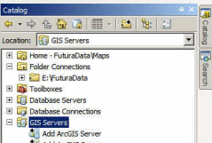

The following illustrate the wizard-driven process where Server URL is the ArcGIS Server site

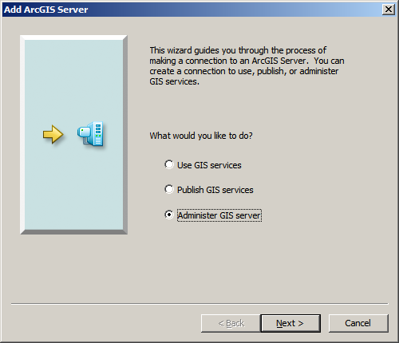 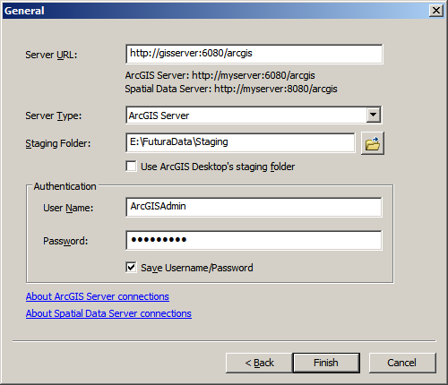

1. Can Share as service from ArcCatalog (always opens ArcMap) or ArcMap
2. Analyze process (describe other processes)
3. If the map used for publishing to a service is changed in any way, changes will not be reflected in service until the map is re-published to service. Use the Overwrite existing service option for this process. You do not have to stop the existing service.

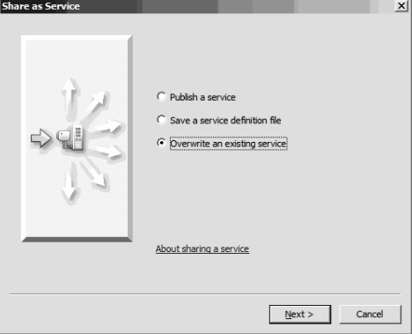

**Designing maps for use with Futura Web Map**

ESRI provides some helpful information for preparing a map document for use as a web map. Be sure to read the following help topic to make sure you’re following the best practices for using ArcGIS Server Web Maps:

<http://resources.arcgis.com/en/help/main/10.1/index.html#/Map_authoring_considerations/0154000003zp000000/>

To improve the performance of the map service when used in the Futura Web Map, use the same map coordinate system that the ArcGIS Online services use. Please refer to the following help topic for information about changing your map document to use this coordinate system:

<http://resources.arcgis.com/en/help/main/10.1/index.html#/Designing_a_map_to_overlay_ArcGIS_Online_Google_Maps_or_Bing_Maps/0154000002r6000000/>

Once your map is ready for publication, use the information in the following help topic to create the map service. Remember to store your Map Services in the Maps folder on the server, and to enable the FuturaNetworkAnalysis and FuturaQuery options on the Capabilities tab:

<http://resources.arcgis.com/en/help/main/10.1/index.html#/How_to_publish_a_service/0154000004n3000000/>

If you use Landbase data in your map that doesn’t frequently change, consider creating a separate map and map service and caching that map service for better performance. For more information about Caching map services, please refer to the following help topic and the other topics in the *Map service caches* section of the ArcGIS Help 10.1.

<http://resources.arcgis.com/en/help/main/10.1/index.html#/A_quick_tour_of_map_caching/01540000040s000000/>

In order to use the Futura Flow Arrows tool, the Feature Access option must be enabled on the map service. The first topic below describes some additional design considerations for Feature Access-enabled services, and the second topic explains how to enable Feature Access on the map service

*Designing a map for feature access:*

<http://resources.arcgis.com/en/help/main/10.1/index.html#/Authoring_feature_services/0154000003nt000000/>

*Setting the map service properties:*

<http://resources.arcgis.com/en/help/main/10.1/index.html#/Setting_map_service_properties/0154000003p1000000/>

**Working with the Futura Web Map**

The Futura Web Map was developed with the ArcGIS API for Silverlight. Futura has developed Add-ins to the ESRI-provided ArcGIS Viewer for Silverlight using this development model to provide the following custom functionality:

* Navigation tools
* Search and Identify tools
* Network Attributes and Network Tracing tools
* Feature layer tool
* Custom behaviors

Futura has provided a pre-made web map for you, but if you’d like to create your own, navigate to:

http://<servername>/Builder (replacing <servername> with the name of your web server)

Click *Create New Application* to start a new web site from scratch, or click the pencil icon next to FuturaWebMap to customize the existing application. A Copy button will let you make a copy of an existing web map, if you’d like to experiment but not change the original web map.

Until you get used to the application builder, use the Getting Started window to navigate. The window will show you how to use the interface and provides a mini-tutorial on using the builder. The help topics for the Silverlight Builder can be accessed using the Help link in the upper right. For your reference, here is a link to the main web help for the Application Builder:

<http://resources.arcgis.com/en/help/silverlight-viewer/concepts/index.html#/Application_Builder/01770000000n000000/>

*Using the tools Futura provides*

Under the Tools tab in Application Builder, click Manage. In the list of Available tools you will find the following functionality:

|  |  |  |
| --- | --- | --- |
| **Tool name** | **Description** | **Considerations** |
| *Futura Electric Tools* |  |  |
| Display Flow Arrows | Display the flow arrows on conductor layers | Feature Access must be enabled on the map service |
| Network Attributes Tool | Display the Network Attributes of the feature, similar to Futura Map’s Network Attribute tool |  |
| Network Tracing Tool | Opens the Utility Network Trace Tools, a toolbar with options for tracing the network. |  |
| *Futura Toolbar* |  |  |
| Futura Full Extent Tool | Zooms the map to the full extent | Full extent is defined as the visible extent when the web map is Saved in Application Builder |
| Futura Next Extent Tool | After using the Previous Extent Tool, the Next Extent will return the view. |  |
| Futura Pan Tool | Pan the map |  |
| Futura Previous Extent Tool | Go to the Previous Visible Extent of the map. |  |
| Futura Zoom-In Tool | Draw a box to zoom in to a particular area |  |
| Futura Zoom-Out Tool | Draw a box to zoom out from an extent. |  |
| *Futura Tools* |  |  |
| Futura Layer Tool | Displays the attributes of a particular layer and allows for more powerful interaction with features. | The tool must be configured to point to a particular layer. See more details below. |
| Futura Search Tool | Search for features in a layer in the map service. | See additional details below. |
| Futura Identify Tool | Identify features in the map service with additional information. | Returns information from the tables related to the features. |

*Additional considerations*

* The Identify, Network Attributes, Flow Arrows, and Tracing tools work for only one mapservice, even if a site has more than one mapservice with the Server Object Extension enabled.
* The Zoom In tool must be added to support the Zoom Previous and Zoom Next tools.
* When configuring the Futura Layer Tool, use the ArcGIS Server Rest Services Directory to find the layer in the map service you want to use.
  + Go to: http://<servername>:6080/arcgis/rest
  + Click on the folder, Maps
  + Click on the name of your map service.
  + Under Layers, click on the Layer you’d like to query (ex: Customers)
  + When the Layer: Consumer page opens, copy the URL in the web browser.
  + In Application Builder, go to Tools > Manage, and add the Futura Layer tool from Available tools to Current Toolbars using the blue >> button.
  + Highlight the tool under Current Toolbars and click the Edit button.
  + In the Edit Tool window, click Configure.
  + In the Layer Configuration window, paste the URL you copied from the Layer: Consumer page. Close the Layer Configuration window.
  + Optionally, change the Label, Tooltip or Icon for this tool. Click OK in the Edit Tool Dialog.
  + Click Close in the Manage Toolbars dialog.
  + Click the button for the Futura Layer tool on the toolbar. The attribute window for the layer will appear, and behaves similarly to the attribute window in ArcMap.
  + For an illustration, see the *Graphic: Configure the Futura Layer* tool below.
* The Futura Search tool can be configured with any dynamic map service (e.g. COOP_Operations) The Search Tool requires configuration and can be preset from the FuturaSearch section contained in the MobileConfig.xml. Once applied in the XML tab on the Search UI Tool, you can use the UI to add new search configurations. It works the same as the Search configuration in Futura mapping.
* Futura provides a Map Gallery to distribute to your colleagues. Add a link to map gallery (http://<serverName>/FuturaWebMaps) under Layout > Title and Links.
* If the client has their own basemap, the Map Service must be cached to use it in the Application Builder. The following link provides the steps to configure a map service for use as a basemap:

<http://resources.arcgis.com/en/help/silverlight-viewer/concepts/index.html#/Configuring_basemaps/01770000000t000000/>

**Graphic: Configure the Futura Layer Tool**

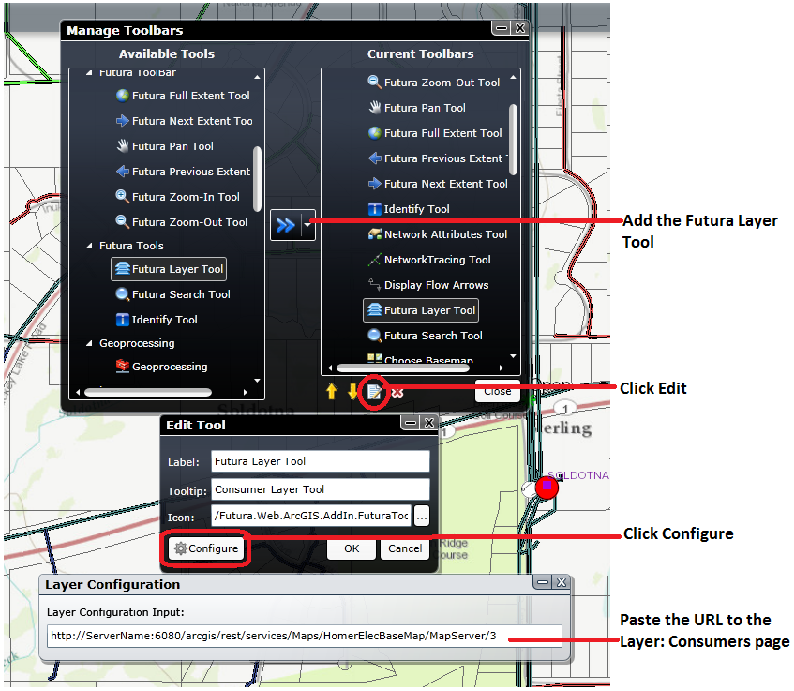

**Graphic: Configure Map Behaviors for UPN View Map in Builder**

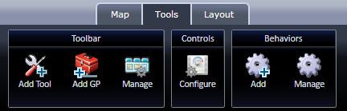

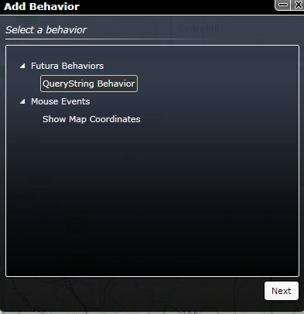

 Click Next

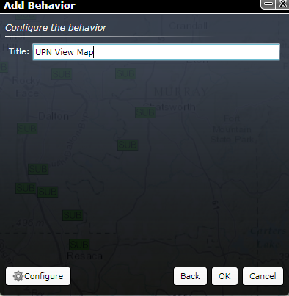

Click Configure and set at least one Layer Name with Field Name and Zoom Scale

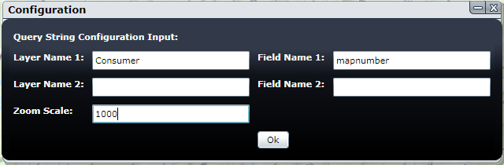

To change Configuration, use Manage on Tools



Machine generated alternative text: ,, ,
1